E-LEARNING WEBSITE AUDITING AND DIGITAL MARKETING IMPLEMENTATION
A Website Audit and Improvement Proposal for Udemy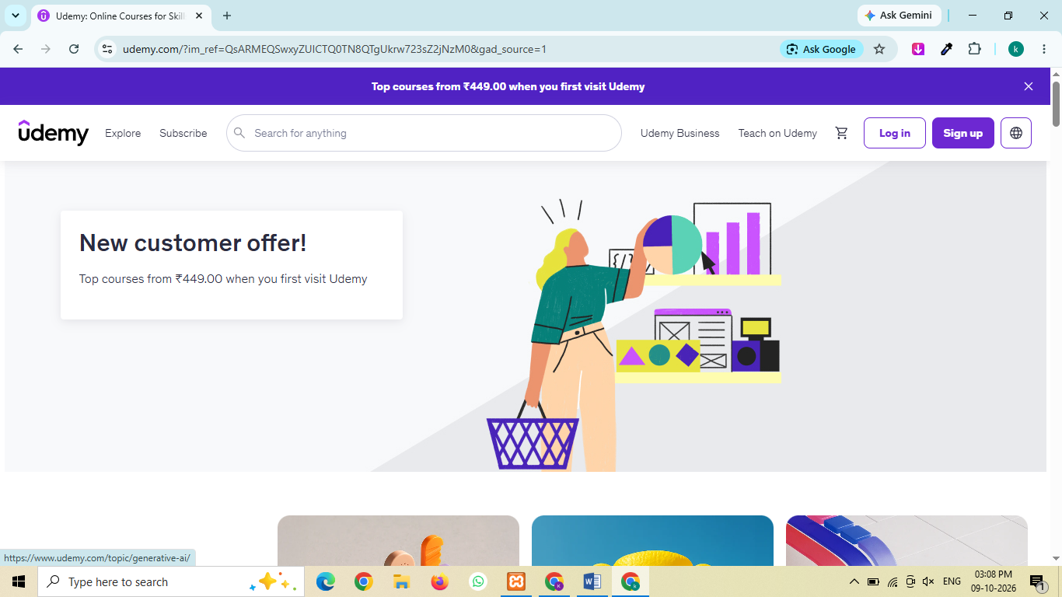
Project prepared by: Khushi Bansal
Internship/Programme: Digital Marketing
Website selected: https://www.udemy.com/

1. Introduction
For this internship project, I selected Udemy, an online learning platform where people can explore courses on different subjects and learn new skills. I chose this website because I wanted to understand how an e-learning platform presents its courses and attracts learners online.
I will in this report review the parts of Udemy's website that are publicly accessible and identify areas where improvements could be considered.
Based on my observations, I will suggest changes to the website experience and prepare a basic digital marketing plan. This will include keyword ideas, content suggestions, social media activities, a sample advertising plan and ways to measure performance.

2. Project Objectives
The main objective of this project is to gain practical knowledge of website auditing and digital marketing by studying an existing e-learning website.
The specific objectives are:
- To review Udemy's website layout, navigation and course information.
- To identify possible improvements in user experience and website content.
- To understand the role of on-page, off-page and technical SEO.
- To research keywords related to online courses and skill development.
- To prepare a content marketing plan for blogs, educational posts and social media.
- To suggest suitable social media promotion activities.
- To prepare a sample paid advertising campaign using Google Ads and Facebook or Instagram Ads.
- To identify useful metrics for measuring website and marketing performance.

3. Project Scope
This project focuses on Udemy's publicly accessible website, including its homepage, course search results and selected course pages. The review covers website design, navigation, course content and basic SEO considerations.
The project also includes a website redesign proposal, keyword research, a content calendar, social media recommendations, a sample paid advertising plan and an analytics measurement plan.
The findings and recommendations will be used to prepare a structured report and presentation. The scope is limited to the information and tools available for this project.

4. Overview of the Selected Website
Website name: Udemy
Website URL: https://www.udemy.com/
Website category: E-learning and online education
Udemy provides an online platform where learners can explore courses in areas such as technology, business, design and personal development. People can use the website to search for subjects they are interested in and compare available learning options.
From a digital marketing perspective, Udemy is a useful website to study because course discovery, informative content, search visibility and user experience can all influence how visitors interact with an e-learning platform.

Udemy homepage
Figure 1: Udemy homepage showing its navigation menu, search bar and promotional banner.

5. Website Audit
A website audit involves reviewing a website to understand what is working well and where improvements may be useful. For this project, I will review five main areas: user experience, content, on-page SEO, technical SEO and off-page SEO.

5.1 User Experience and Website Design
The user experience review focuses on how easily visitors can navigate the website and find courses that match their interests.
I will examine the homepage, search bar, course listings and an individual course page. I will also consider whether the page layout is clear and whether important course information is easy to find.
The main points to review are:
- Visibility and usability of the search bar.
- Clarity of the navigation menu and course categories.
- Ease of finding and comparing courses.
- Readability of course descriptions and other information.
- Usability on mobile devices.
Possible improvement: If the review shows that important course details are difficult to find, the page layout could be simplified to make those details easier to compare.

5.2 Content Review
Website content should help visitors understand what a course offers and whether it matches their needs.
I will review course titles, descriptions, learning objectives and instructor information on a selected course page. I will also consider whether the information is clearly organised and easy to understand.
Possible improvement: Course information could be organised with clear headings and concise explanations so learners can quickly understand the main topics and expected learning outcomes.
Screenshot 2: Insert a screenshot of a course page showing its title and course information.

5.3 On-Page SEO
On-page SEO involves improving the content and structure of individual web pages so that search engines and visitors can understand them more easily.
The review will consider:
- Page titles and headings, where observable.
- Relevance and clarity of page content.
- Use of descriptive links and internal navigation.
- Image descriptions and alt text, where they can be assessed.
- Whether the content matches the likely search intent of learners.
Possible improvement: Educational content should use clear headings and relevant terms naturally, while answering the questions that potential learners may have.

5.4 Technical SEO
Technical SEO covers factors that affect a website's crawling, indexing, performance and usability.
For this project, I will use PageSpeed Insights to check the performance of the publicly accessible website. I will also consider its appearance and usability on a mobile screen.
The results should be recorded using the actual scores and observations returned by the tool. A single performance test does not establish that every technical SEO issue has been checked.
Screenshot 3: Insert your actual PageSpeed Insights result for Udemy.

5.5 Off-Page SEO
Off-page SEO includes activities outside a website that may support its visibility and reputation, such as relevant backlinks, brand mentions and useful content shared by other websites.
For an e-learning platform, possible opportunities include publishing helpful educational resources, collaborating with relevant publishers and encouraging genuine references to useful content.
A detailed backlink assessment would require an appropriate SEO tool. I will not assume that a backlink issue exists without supporting evidence.

5.6 Website Audit Summary
Complete the following table after checking the website.
Audit area | What I reviewed | Observation
User experience | Homepage, navigation and search bar | The homepage has a visible search bar and navigation menu, which help visitors begin looking for courses.
Content | Course title and description | Udemy’s course pages include details such as the course title, summary, instructor information and price. These details help learners understand what a course offers and decide whether it suits their needs. (fig 2)
On-page SEO | Headings and visible page content | Page title: The title is “Online Courses - Learn Anything, On Your Schedule.” It clearly describes Udemy's purpose and includes relevant wording about online course.  Meta Description: The description explains that Udemy is an online learning and teaching marketplace and mentions subjects such as programming, marketing and data science. This helps visitors understand the types of courses available. (fig 3)
Technical SEO | Page Speed Insights and mobile usability | The PageSpeed Insights desktop test gave Udemy a Performance score of 46, while Accessibility scored 94, Best Practices 96 and SEO 92.  The report also highlighted opportunities to improve image delivery, browser caching and render-blocking requests. These improvements could help make the website load faster. (fig 4)
Off-page SEO | Backlinks and external mentions | According to Ahrefs' free Backlink Checker, Udemy has a Domain Rating of 91, approximately 17 million backlinks and 125,000 linking websites. These figures indicate a substantial backlink profile. However, the quality and relevance of individual backlinks would ne (fig 5)

Figure 2: Udemy homepage showing course content and learning categories.
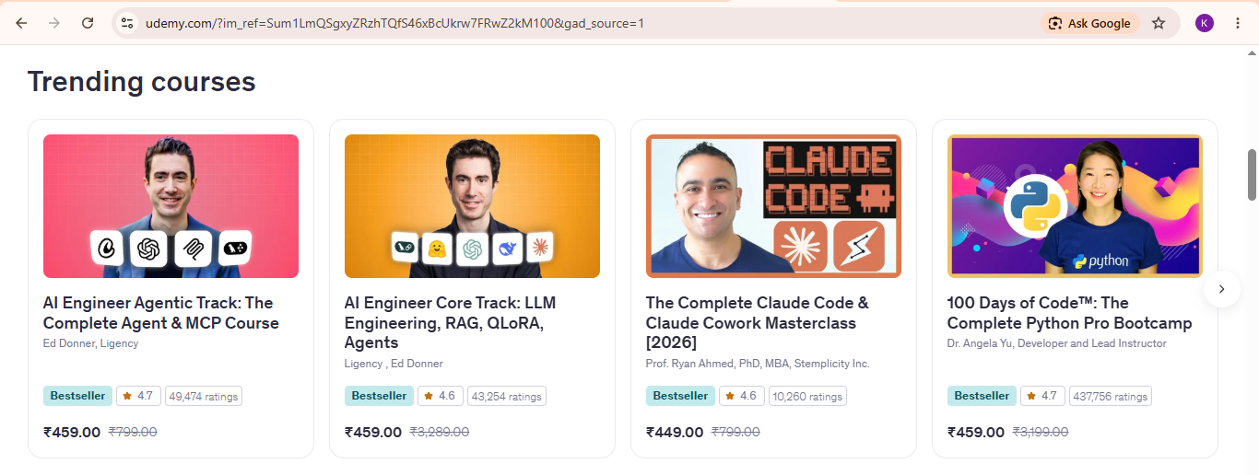

Figure 3: Checking Udemy’s page title and meta description in the HTML source code.

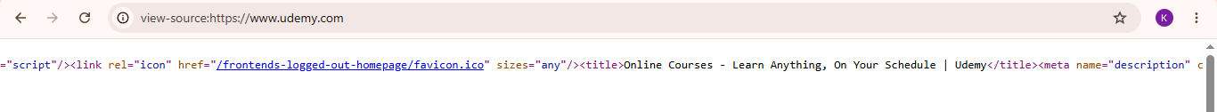
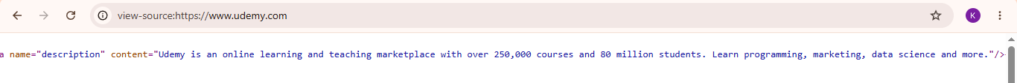

Figure 4: PageSpeed Insights showing opportunities to improve image delivery, caching and page loading.
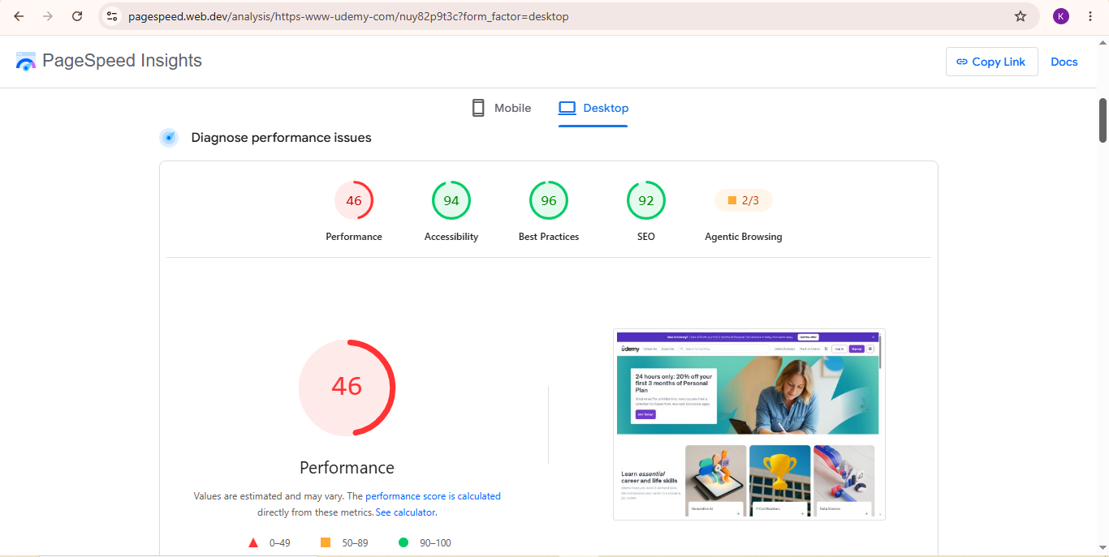
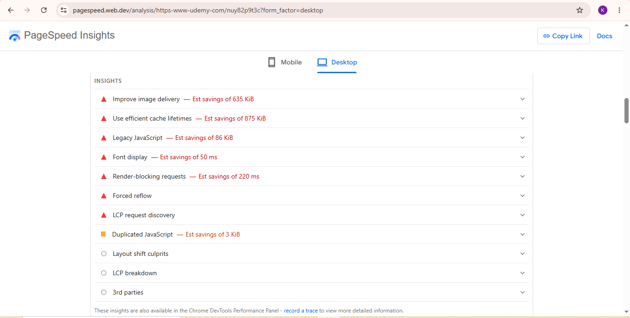

Figure 5: Ahrefs Backlink Checker showing Udemy’s backlink profile.
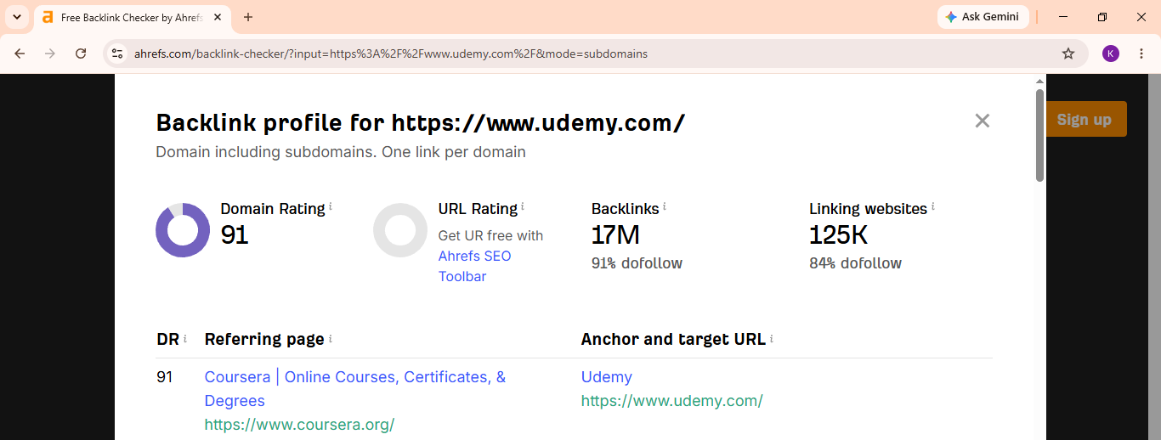

6. Website Redesign Proposal
Based on the website audit, I have identified a few areas where Udemy’s website experience could be improved. The aim of this proposal is to make it easier for learners to find suitable courses, understand course details and make informed decisions.

6.1 Proposed Improvements
1. Improve course discovery
Udemy already provides a search bar and course categories. These features could be made more useful by helping learners filter courses based on their skill level, budget, duration and learning goals.
2. Make course information easier to compare
Course pages should present important information, such as course content, instructor details, ratings, duration and price, in a clear and organised way. This would help learners compare options before choosing a course.
3. Improve page loading speed
The PageSpeed Insights test highlighted opportunities to improve performance. Optimising images, improving browser caching and reducing unnecessary JavaScript could help make pages load more efficiently.
4. Improve mobile usability
Many learners use mobile devices to browse online courses. Buttons, course details, filters and navigation should remain easy to read and use on smaller screens.

6.2 Proposed Website Layout
The following layout is a suggested improvement plan, not a claim that the existing website has been redesigned.
- Header: Udemy logo, search bar, categories and account options.
- Main banner: A clear headline encouraging learners to explore new skills.
- Popular categories: Sections for areas such as development, business, design and marketing.
- Recommended courses: Course cards showing titles, ratings, prices and relevant labels.
- Course details: A clear summary, learning objectives, instructor information and course content.
- Student support: Frequently asked questions and information to help learners choose a suitable course.
A clean layout with consistent spacing, readable text and clear buttons could make course discovery easier.

6.3 Expected Benefits
The proposed changes could help learners find relevant courses more easily, understand course information and navigate the website with less difficulty. Better page performance may also improve the browsing experience. These are expected benefits; actual results would need to be measured after implementation.

7. Keyword Research and SEO Strategy
Search engine optimisation (SEO) helps a website appear in relevant search results. For this project, I have selected keyword ideas related to online learning and professional skill development.

7.1 Keyword Research
The following are initial keyword ideas for planning purposes. Search volume, competition and user intent should be checked using tools such as Google Keyword Planner, Google Trends or another keyword research tool before finalising the strategy.
Keyword | Suggested use
Online courses | Homepage and main landing pages
Online courses for beginners | Beginner-focused content
Digital marketing course | Digital marketing course pages
Python programming course | Programming-related pages
Data science courses | Data science category pages
AI courses online | AI and technology course pages
Learn web development | Web development content
Online certification courses | Relevant course and category pages

7.2 On-Page SEO Strategy
The following actions could support Udemy’s on-page SEO:
- Use clear page titles that describe the page content.
- Write relevant meta descriptions to encourage users to visit the website.
- Organise content with appropriate headings.
- Use descriptive text for images where suitable.
- Add relevant internal links between course pages and related learning resources.
- Keep course descriptions useful, original and easy to understand.
- Use keywords naturally rather than repeating them unnecessarily.
During my audit, I checked Udemy’s homepage title and meta description through its HTML source. The title and description clearly communicate the website’s online learning purpose.

7.3 Technical SEO Strategy
Based on the PageSpeed Insights results reviewed in this report, the following improvements could be considered:
- Optimise large images to reduce file sizes.
- Use effective browser caching where appropriate.
- Reduce unnecessary JavaScript and other resources that delay page rendering.
- Review mobile performance and usability.
- Check for broken links and indexing issues.
- Monitor Core Web Vitals and page performance over time.
These recommendations would need further testing and technical review before implementation.

7.4 Off-Page SEO Strategy
Off-page SEO includes activities that help build a website’s reputation and visibility outside its own pages.
Suggested activities include:
- Create useful learning guides that other websites may want to reference.
- Build relationships with relevant education and career websites.
- Encourage instructors to share their course pages through appropriate channels.
- Share useful educational content on social media.
- Review backlinks periodically to identify relevant links and potential issues.
Ahrefs’ free Backlink Checker showed a substantial backlink profile for Udemy. However, the number of backlinks alone does not establish the quality of every link.

7.5 Measuring SEO Performance
SEO performance could be monitored using Google Search Console and Google Analytics 4 (GA4), where access and tracking are available.
Important metrics include:
- Organic clicks and impressions.
- Search queries bringing visitors to the website.
- Click-through rate (CTR).
- Average search position.
- Organic landing-page traffic.
- Engagement and important conversion events.

8. Content Marketing Strategy
Content marketing involves creating useful and relevant content to attract an audience, answer questions and encourage people to explore a website.
For Udemy, content could focus on helping learners understand which skills to develop, how to begin learning and how different courses may support their goals.

8.1 Proposed Content Ideas
Blog posts
- How to Start Learning Digital Marketing as a Beginner
- Python for Beginners: A Simple Learning Roadmap
- Which Digital Skills Are Useful for Career Development?
- How to Choose the Right Online Course
- AI Skills Beginners Can Start Learning
Website content
- Beginner-friendly course collection pages.
- Learning guides organised by subject.
- Course comparison pages with clear and relevant information.
- Frequently asked questions about choosing online courses.
Social media content
- Short educational tips.
- Course highlights.
- Learning roadmaps and checklists.
- Polls asking followers which skills they want to learn.
- Short videos explaining a useful concept.
These are proposed content ideas and would need to be reviewed for relevance, accuracy and search demand before publication.

8.2 Four-Week Content Calendar
Week | Content idea | Platform | Objective
Week 1 | Beginner’s guide to digital marketing | Blog and LinkedIn | Attract learners interested in marketing
Week 2 | Python learning roadmap | Blog and Instagram | Share useful learning advice
Week 3 | Tips for choosing an online course | Blog and Facebook | Help users compare courses
Week 4 | Short video on useful AI skills | Instagram and YouTube Shorts | Increase awareness and engagement
The content should provide value rather than only promoting courses.
Links to relevant course pages can be included where appropriate.

8.3 Content Performance Measurement
The content plan could be evaluated by tracking:
- Page views and organic visits.
- Time spent engaging with content.
- Social media reach and engagement.
- Link clicks to relevant course pages.
- Newsletter sign-ups or other available conversion events.
The results would help identify which topics attract the most interest and should be developed further.

9. Social Media Marketing Strategy
Social media can help an e-learning platform reach potential learners, share useful information and increase awareness of its courses.

9.1 Proposed Platforms
Instagram: Share short learning tips, reels, course highlights and educational carousels.
Facebook: Share learning resources, course information and relevant educational posts.
LinkedIn: Publish career-related learning advice, professional development content and skill-building resources.
YouTube: Share tutorials, short educational videos and learning guides.
The content should be adapted to each platform instead of posting exactly the same material everywhere.

9.2 Sample Weekly Posting Plan
Day | Content | Platform
Monday | A tip for learning a new skill | Instagram
Tuesday | A career development or learning post | LinkedIn
Wednesday | A course or subject highlight | Facebook
Friday | A short educational video | Instagram and YouTube Shorts
Saturday | A poll or question for learners | Instagram Stories
This is a suggested schedule. The frequency can be adjusted based on audience response and available resources.

9.3 Social Bookmarking and Content Sharing
Social bookmarking and content-sharing activities can help people discover useful resources. Relevant educational articles could be shared on suitable platforms and communities where such sharing is permitted.
The focus should be on providing helpful information, following community rules and avoiding spam or repeated promotional links.

9.4 Social Media Measurement
Performance could be measured through:
- Reach and impressions.
- Likes, comments, shares and saves.
- Video views and completion rates.
- Website visits from social media.
- Clicks on course links.
- Conversions, where tracking is available.
These metrics can help determine which content formats and topics work best.

10. Paid Advertising Campaign Proposal
Paid advertising can help reach people who are actively searching for learning opportunities or who may be interested in developing new skills.
For this project, I have prepared a sample campaign plan using Google Ads and Meta Ads. This is a proposed budget, not an actual campaign spend or a report of live advertising results.

10.1 Campaign Objectives
The main objectives would be to:
- Increase awareness of relevant online courses.
- Bring interested users to suitable course or category pages.
- Encourage users to explore course details.
- Measure clicks and meaningful actions on the website.

10.2 Proposed Budget
Advertising platform | Proposed budget | Purpose
Google Search Ads | ₹3,000 | Reach people searching for relevant courses
Meta Ads (Facebook and Instagram) | ₹2,000 | Reach audiences interested in learning and skill development
Total | ₹5,000 | Illustrative campaign budget

10.3 Google Search Ads
A sample campaign could target relevant search terms, such as “online digital marketing course” or “Python course for beginners.”
The ads should use clear headlines, relevant descriptions and a link to the appropriate course page. Keyword selection should be based on actual search demand, competition and campaign goals.

Sample ad copy
Headline: Explore Online Courses
Description: Discover courses to help you develop new skills and learn at your own pace.
Call to action: Explore Courses
This is sample advertising copy, not a live advertisement.

10.4 Meta Ads
Facebook and Instagram ads could use simple visuals or short videos highlighting learning opportunities.
The creative could focus on a learner’s goal, such as learning a new skill or exploring a new subject. The ad should direct users to a relevant landing page rather than a general page that does not match the message.

10.5 Measuring Advertising Performance
The campaign could be evaluated using:
- Impressions and reach.
- Click-through rate.
- Cost per click.
- Landing-page visits.
- Conversions and cost per conversion, where tracking is available.
The campaign should be tested and optimised based on actual performance data. Results should not be assumed before the campaign runs.

11. Analytics and Performance Reporting
Analytics helps measure whether website and marketing activities are meeting their objectives. It can also show which channels bring visitors and which content attracts attention.

11.1 Tools for Measurement
Google Analytics 4 (GA4): Can measure website traffic, engagement and configured events or conversions when the tracking code is installed and working.
Google Search Console: Can provide information about organic search impressions, clicks, queries and indexing.
Google PageSpeed Insights: Can assess page performance and identify possible technical improvements.
Google Ads and Meta Ads Manager: Can report campaign delivery, clicks, costs and conversions for campaigns run through those platforms.
These tools would need to be configured appropriately, and access to private account data would be required for a complete performance report.

11.2 Key Performance Indicators (KPIs)
Area | KPI | Purpose
SEO | Organic clicks and impressions | Understand search visibility
Website | Page loading performance | Identify technical improvements
Content | Page views and engagement | Assess content usefulness
Social media | Reach, shares and engagement | Measure audience response
Paid advertising | CTR and cost per click | Evaluate ad efficiency
Conversions | Tracked conversion events | Understand whether visitors take desired actions

11.3 Reporting Plan
Performance could be reviewed monthly using a simple report containing the KPI, the current result, the previous period’s result and any recommended action.
For example, if a blog post receives many impressions but few clicks, its title and search snippet could be reviewed. If a page has poor loading performance, its images and scripts could be checked.
Because this project is based on a public website audit and proposed marketing activities, I have not claimed access to Udemy’s private analytics or actual campaign results. These would be required to confirm the real impact of any changes.

12. Project Implementation Timeline
The following is a proposed eight-week timeline for carrying out the recommended activities.
Week | Activity | Expected output
1 | Website review and initial audit | Audit findings
2 | Keyword research and competitor review | Initial keyword list
3 | Prepare redesign recommendations | Website redesign proposal
4 | Develop content ideas and calendar | Content marketing plan
5 | Prepare SEO recommendations | SEO action plan
6 | Plan social media activities | Social media schedule
7 | Prepare paid advertising campaign | Sample ad copy and budget
8 | Define measurement methods and prepare final report | KPI plan and project report

13. Challenges and Learning
During this project, I learned that a website audit involves more than looking at how a website appears. It also requires checking content, SEO elements, technical performance and how users find information.
One challenge was understanding the technical information provided by PageSpeed Insights. The different scores and performance recommendations were new to me, so I had to review what they meant and connect them to possible website improvements.
Another challenge was checking off-page SEO. The Ahrefs backlink report provided figures for backlinks and linking websites, but I learned that these numbers do not automatically tell us whether every backlink is useful or relevant.
Planning the marketing strategy was also a learning experience. I had to consider how keyword research, useful content, social media and paid advertising could work together rather than treating them as separate activities.
Overall, this project helped me understand the basic process of reviewing a website, identifying possible improvements and preparing a digital marketing plan based on the findings.

14. Conclusion
This project helped me understand how a website audit can support a digital marketing strategy. By reviewing Udemy’s publicly accessible website, I examined its course content, on-page SEO, technical performance and backlink profile.
The audit identified areas that could be explored further, particularly website performance, course discovery and the organisation of course information. Based on these findings, I prepared recommendations for website improvements, keyword targeting, content marketing, social media promotion, paid advertising and performance measurement.
The proposed strategies are intended to help improve the learner experience and support online visibility. However, their effectiveness would need to be evaluated using actual website analytics, search performance data and campaign results after implementation.
Overall, this internship project gave me practical experience in website auditing and helped me understand how different digital marketing activities can support one another.

15. References
The following sources were consulted or can be used to verify the website and tools discussed in this report.
- Udemy official website: https://www.udemy.com/
- Google PageSpeed Insights: https://pagespeed.web.dev/
- Ahrefs Free Backlink Checker: https://ahrefs.com/backlink-checker
- Google Search Console: https://search.google.com/search-console/about
- Google Analytics: https://analytics.google.com/
- Google Keyword Planner: https://ads.google.com/home/tools/keyword-planner/
- Google Trends: https://trends.google.com/trends/
- Google Ads: https://ads.google.com/
- Meta for Business: https://www.facebook.com/business/

